The Art of Spiritual Transformation
Mystical Gateways into the Heart
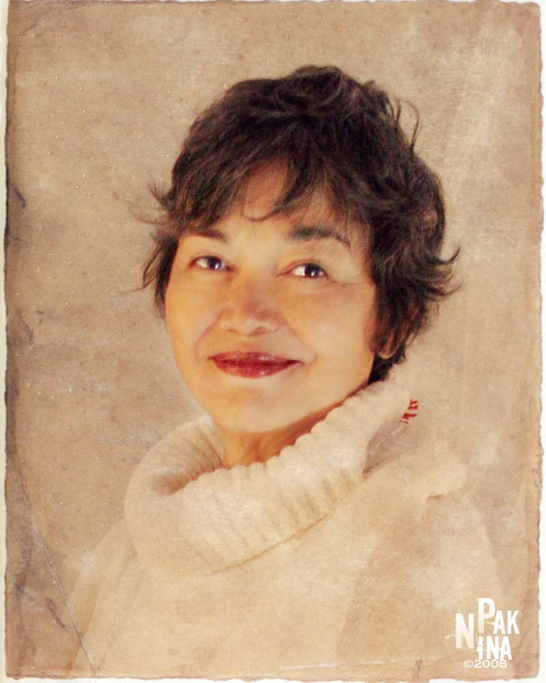
Maria Elena Cairo

November 7-9, 2008
San Diego, CA

Friday 6:30 pm – Sunday 12:30 pm
INNER DOORS OF TRANSFORMATION & RENEWAL
Please join us this joyful weekend where we will be combining the approach to the Mystery with
meditation, dream work, sacred story telling, and deeksha - The Oneness Blessing (Deeksha)
for a unique combination that accelerates breakthrough realizations of consciousness.
Deeksha means: “blessing or initiation” in Sanskrit

Oneness Blessing or Deeksha is a transmission of energy that affects the activity of the brain leading to heightened states of consciousness and meditation. “Anything can be transferred, be it states of consciousness, wisdom or energy.” In many Eastern traditions, it has been used by masters to transfer spiritual experiences, and the practice of laying-on of hands exists in many traditions throughout the world.

For More Information
Heather O'Quinn 760-716-4006 or heathero@shopdreamy.com
Tara Teipel 858-472-1971 or taranel@earthlink.net
$300 before 10/7/08 - or $350 after
Register Online
www.MariaElenaCairo.com

